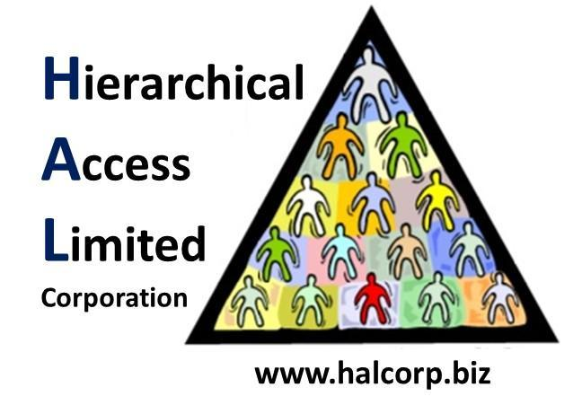

Internal Memorandum

**To: CISO**

**CC:**

**From:** Michael Ibeh

**Date: 10/21/2018**

**Memo #: 0002**

**Re:** Hacker Snacks

Greetings,

As hackers, we can work up quite an appetite. Our favorite snacks are Blackfin tuna sushi, Flaming Hot Cheetos, and Krispy Kreme donuts.

Regards,

Team B